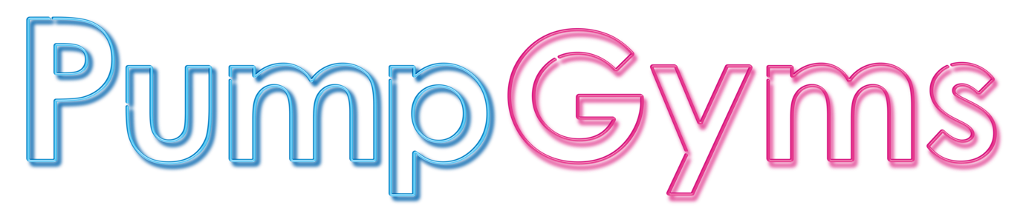
CLASS DESCRIPTION
ABS CIRCUITS/BLAST
A power class designed solely to work the abdominals. You will be shown a variety of techniques to burn fat and tone those abs.

CIRCUITS
A full body workout. The studio is set up with various stations, your move around the stations working all muscle groups. This class will work cardio and strength all throughout one class.

TOTAL BODY WORKOUT
An intense whole-body workout designed to hit every muscle group making sure you get the best workout. This class is designed to work your strength and cardio all within one session.

HIIT BLAST/TOTAL BODY HIIT
Hight intensity interval training, a non-stop class to really get the heart rate up and the blood pumping. This will really focus on your cardio

LBT – Legs, Bums and Tums
A class focusing on legs, bums and tums. This workout will include weighted and body weight exercises along with some cardio but always focusing on these areas.

PILATES
Pilates improves flexibility, builds strength and develops control and endurance in the entire body. It puts emphasis on alignment, breathing, developing a strong core and improving coordination and balance.

RIG FIT
A circuit session using the RIG station on the gym floor. Within this session you will use all functional equipment such as battle ropes, dipping stations, slam balls, kettlebells, weighted bars and much more. You will work every muscle group whilst working on your overall fitness.

SPIN
A challenging class carried out to music on specially designed bikes.
A great way to improve fitness and stamina using a variety of cycling techniques.

ZUMBA
Zumba combines Latin and International music with a fun and effective dance workout system. A total workout, combining all elements of fitness – cardio, muscle conditioning, balance and flexibility, boosted energy and a serious dose of awesome each time you leave class.

BOOTCAMP
Get pushed to your limits. Focusing on high intensity interval training to help you reach your goals. Incorporating military style exercises into a fun, high intensity, circuit style format.

KETTLEBELLS
A complete full body workout using only Kettlebells. Designed to improve your functional fitness as well as increase your fitness. Kettlebells will test your stability and flexibility in a way you can’t replicate using traditional free weights.

BARBELL BLAST
A full body workout utilizing barbells and free weights. Get a total body workout using resistance designed to improve strength, build muscle and develop all the muscles in your body.

BOXERCISE
Boxercise is an exercise concept based on the training methods used by boxers. Sessions typically involve hitting focus pads, but no class involves hitting an opponent. It is a fun, challenging and safe workout which is great for stress busting, accessible to all ages and fitness levels.

ROCKFIT
RockFit is a high intensity workout set to a Rock’n’roll soundtrack. The combination of Rock music, dance fitness and some serious body sculpting moves make this one epic workout.

